Final Design Package for the Not-a-Boring Competition 2025

Vertical Drilling Machine

2024-11-29

Point of contact: Peter Bremermann

Email: hyperloop@engsoc.queensu.ca

# Table of Contents

Table of Contents i

List of Figures iii

List of Tables iv

1. Team Description 5

1.1 Team Members 5

1.2 Team Advisors 6

2. Design Description for Digging Device 7

2.1 Site Investigation and Design 7

2.1.1 Soil Analysis 7

2.1.2 Soil Testing Design 12

2.2 Machine Top-Level Design Summary and Layout 13

2.2.1 Cutter Head 13

2.2.2 Cutterhead Rotation System 16

2.2.3 Soil Removal System 19

2.2.4 Soil Removal Rotation System 21

2.2.5 Shield and Support 23

2.2.6 Protection around machine 26

2.2.7 Drill Lift System 26

2.2.8 Power System 28

2.2.9 Software System 30

2.3 Machine Dimensions and Mass 31

2.4 Digging Machine Parameters 31

3. High level Design calculations of your machine. At a minimum, this should include: 32

3.1. Machine Structural Analysis 32

3.1.1. Digging machine itself 32

3.1.2. Launch and/or supporting structures 33

3.2. Control System - Hardware 34

3.2.1 Sensor list and location map 34

3.2.2 Control Unit 37

3.2.3 Electronic Schematic 37

3.3. Control Systems - Software 38

3.3.1 Frontend 39

3.3.2 Backend 40

3.4 Estimated thermal output 40

3.4.1 By subsystem 40

4. Safety Interlock Mechanism Flow Chart 41

5. Equipment lifting and transportation structural analysis 42

5.1 Lift Procedure 42

Pre Lift 42

Lift Team 42

Lift Procedure 42

5.1.1Emergency Lift Procedure 43

5.2 Lift Procedure for Competition 43

5.3 Transportation Plan and Analysis 43

Plan A: Mid-Size SUV Transportation 43

Plan BBBBBBBBA: FedEx Land Freight by Truck 44

5.4 Transportation load analysis 45

5.4.1 Road Transportation 45

5.4.2 Securing machine 46

5.4.3 First principles calculation for safety factor 46

6. Subsystem and full machine functional test program before arrival for competition week 47

Test Procedures for High Voltage scenarios 47

6.1 VBM Testing Procedures 48

6.1.1 Rotating of cutterhead (with clay) 48

6.1.2 Auger rotation testing (with clay) 48

6.1.3 Structural testing 48

6.1.4 Control and software Testing 49

6.1.5 Sensor and data testing 49

6.2 Provide all available test results of tests already conducted 50

7. Machine Production Timeline and Status 50

8. Machine cost breakdown and funding plan 54

9. List and description of any stored energy on the machine 54

10. Description of safety features including: 55

a. Safety plan for working 55

11. Description of System Scalability 59

12. A CAD 3D-model (.step file) and corresponding Bill-of-material (BOM) need to be uploaded together with the FDP 61

12.1 Bill of Materials 62

13. References 63

# List of Figures

Figure 1: Grain size distribution figure. 9

Figure 2: Shear stress graphs B=1 10

Figure 3: shear stress graphs site B-3 11

Figure 4: Stress strain curve B-1 11

Figure 5: Stress strain curve B-3 12

Figure 6. Front view of cutter face concept. 13

Figure 7. Isometric view of cutter face concept, not the final scraper orientation. 14

Figure 8. Diagram of a modelled scraper, with α - Front angle; β - Back angle; γ - Edge angle. 15

Figure 9. Concept sketch of cutter head, showing alternating teeth pattern and spacing (not to scale, all measurements in mm). 15

Figure 10. Isolated isometric view of the shaft system. 16

Figure 11: Motor Schematic for the Marathon GT1026A 18

Figure 12: three- stage planetary gearbox [1]. 19

Figure 13: Shaft couplings [2], [3] 19

Figure 14: Auger Screw for Clay Removal 20

Figure 15: Calculation for the basis of the clay 21

Figure 16: Engineering Drawing of the Marathon X029 22

Figure 17: Worm and worm gears 23

Figure 18: Frame of Digging Machine with Linear Actuators at all four corners 27

Figure 19: Igus Drylin Linear Guide 28

Figure 20: Power Calculations for the cutter head system 29

Figure 21: Power Calculations for the auger system 29

Figure 22: Simplification of Custom Cutterhead CAD 32

Figure 23: Torsion Load FEA, showing max Von Mises of 219 MPa 33

Figure 24: Top View of the Dynamic Platform and Frame and Forces and Moments present 34

Figure 25: Spec of the 20HP motor showing how current and torque are related 35

Figure 26: High Level Sensor Location Map, all electronics not explicitly shown on the drawing will be located in the stack 37

Figure 27: Raspberry Pi Pin Layout Reference 38

Figure 28: Electrical Schematic of the Control System Hardware along with the power supply to the motor. 38

Figure 29: Potential Layout of the GUI. Note Not all contents on figure are expected to be on final GUI, only a prototype. 39

Figure 30: Code snippet for implementing front end. 39

Figure 31: Safety Interlock Mechanism Flow Chart. See section 3.5 for details on the functionality and implementation of the safety interlock system. 41

Figure 32: Proper lifting procedures 43

Figure 33: Cargo hooks in the cargo space of the 2023 Ford Escape. 44

Figure 34: Cargo hooks in the cargo space of the 2023 Ford Escape. 44

Figure 35: Cargo hooks in the cargo space of the 2023 Ford Escape. 44

Figure 36: 2023 Ford Escape to be rented for transportation. 44

Figure 37: Projected FedEx LTL Freight transportation timeline. 45

Figure 38: Examples of items used for securing the VBM in the back of the car [4], [5], 46

Figure 39: Final Design Report 52

Figure 40: Assembly and machine production schedule 53

Figure 41: Raspberry Pi with battery 55

# List of Tables

Table 1:Generalized Soil Material Table 8

Table 2: Cutterhead extraction and speed calculations 17

Table 3: Cutterhead extraction calculations 22

Table 4: Frontend Component Breakdown and Functions 30

Table 5: Machine Dimensions and Mass Breakdown 31

Table 6:Sensor List 36

Table 7: Thermal Output Breakdown 40

Table 8: Team weighted risk matrix 50

Table 9: Preliminary design briefing schedule 51

Table 10: Dean’s Donation Cost Breakdown 54

Table 11: Funding source breakdown 57

Table 12:Risk Identification, description, mitigation, occurrence, severity and response 59

Table 13: Bill of materials. 64

# 1. Team Description

Queen’s Hyperloop Design Team (QHDT) is a dynamic group of over 150 passionate students from Queen’s University in Kingston, Canada. The team shares a vision to change the future of transportation and is committed to pushing the boundaries of innovation and engineering excellence, by leveraging interdisciplinary collaboration amongst the immense talent pool within Queen’s University. This submission clearly shows the teamwork and collective passion the team has contributed towards making tunnel boring a more accessible reality.

This includes a drilling team, a mechanical team and an electrical and software team.

The motivation for the team comes from an interest in making working on a multidisciplinary project related to the earth sciences, infrastructure and technology. The team this year will create a management and working structure that will allow junior as well as senior members to contribute. The way this will be achieved is through experimenting with different styles and approaches while diligently recording everything. The foundational team culture will be important to cultivate. The main tenants will be of innovation and collaboration that will sustain itself for years to come.

## 1.1 Team Members

|  |  |  |  |
| --- | --- | --- | --- |
| Name | Title | Discipline | E-mail Address |
| Claire Hu | Co-Captain | Commerce ‘26 | claire.hu@queensu.ca |
| Ben Rosen | Co-Captain | Mechanical Engineering ‘26 | 20bjlr@queensu.ca |
| Corbin Riches | Co-Captain | Engineering Physics ‘26 | 21clr15@queensu.ca |
| Peter Bremermann | Director of Tunneling and Boring | Geological Engineering ‘26 | 19peb3@queensu.ca |
| Ella Bundza | Boring Drilling Manager | Geological Engineering ‘26 | ella.bundza@queensu.ca |
| Liam Etty | Boring Electrical Manager | Electrical Engineering ‘26 | 21lbe@queensu.ca |
| Joshua Paddock | Boring Mechanical Manager | Mathematics and Engineering ‘26 | josh.paddock@queensu.ca |
| Freddie Anderson | Boring Drilling Designer | Applied Sciences Engineering ‘28 | 23vwh1@queensu.ca |
| Nicolai Basen | Boring Drilling Designer | Geological Engineering ‘26 | 21ntb1@queensu.ca |
| Kim Balayar | Boring Drilling Designer | Geological Engineering ‘27 | 22gj10@queensu.ca |
| Richie Williams | Boring Drilling Designer | Geological Engineering ‘27 | 22vrjm@queensu.ca |
| Shohayb Heddokheel | Boring Drilling Designer | Civil Engineering ‘27 and Computing ‘28 | 22nx31@queensu.ca |
| Momin Alvi | Boring Electrical Designer | Computing ‘26 | momin.alvi@queensu.ca |
| Nelson Zhou | Boring Electrical Designer | Physics ‘26 | 21yz160@queensu.ca |
| Peter Facina | Boring Mechanical Designer | Mechanical Engineering ‘28 | 23sy11@queensu.ca |
| Sapphire Flach | Boring Mechanical Designer | Mining Engineering ‘27 | 22cmh2@queensu.ca |
| Pippa Janidlo | Boring Mechanical Designer | Mechanical Engineering ‘27 | 22lmf2@queensu.ca |

## 1.2 Team Advisors

|  |  |  |
| --- | --- | --- |
| Advisor | Title | Institution |
| Graham Swarbrick | Tunneling and Boring Advisor | Project Engineer at Herrenknecht AG |
| Dr. Geoff Eichhorn | Tunneling and Boring Advisor | Civil Engineering Department at Smith Engineering, Queen’s University |
| Nick Bundza | Tunneling and Boring Advisor | Mechanical Design Engineer at Nokia |

# 2. Design Description for Digging Device

The team is looking to design and manufacture a working vertical digging machine prototype for the Not-a-Boring mini competition in Texas 2025. The team has 3 main streams, who have mapped out the machine design summary. The initial site investigation and analysis yielded important information about the geology in the area, which the rest of the design was based around.

## 2.1 Site Investigation and Design

Important to consider for the design and selection of the preferred tunnelling methods is the geological conditions found in the competition area. The land in the Not-a-Boring competition area has been used for agricultural purposes since 1985. It shows some history of flooding which has altered the depositional environment, introducing gravel layers, sand or silt seams. The primary geological formations in the area, include; Alluvium containing clay and sand mixed with silt and gravel. These deposits have potential for significant variation over short distances. Terrace deposits are also found in the area, and are deposited by stream beds, and contain, clays, sands, silts and gravels. There is also a simsboro formation, consisting of mainly coarse-grained sand deposits, overlying mudstones and claystone layers.

The drilling machine also only needs to dig 1m deep into the subsurface. Although the design should be applicable to the main competition as well, which requires the TBM to have a minimum distance from the top of their tunnel to the surface. The TBM will likely have to have a system that can deal with soil which is 0.5m and deeper. With this informing the interpretation the boreholes yielded two types of dominant geological materials the team will have to consider for the 1m deep hole that the VBM will need to dig. This includes a lean clay with sand and a fat clay. This was provided by the bore hole logs as well as generalized stratigraphy conditions that were provided for each borehole. The generalized conditions provided the basis for this analysis

To be considered within the design are also the site conditions of the area for drilling, Bastrop Texas is located near the Gulf of Mexico and in the competition month of March receives around 53 mm of rain in March and has low humidity the month of the competition. While the temperature tends to range from 24 to 10. This indicates that the site will likely be dry for the competition. This should be considered when performing the soil analysis, as the soil is likely to be quite dry.

### 2.1.1 Soil Analysis

The geotechnical report offers the team a comprehensive overview of the site conditions in Bastrop, the challenge for the team was to find what parts of the report were relevant to the VBM design. From background research and discussions with advisors, the important soil properties include:

* The soil type and classification
* Density and unit weight
* Plasticity and consistency

These are the most critical items for the team to use for predicting potential machine performance. The Geotechnical report offers several different properties and descriptions of the same soils. For the purpose of the design these were generalized into the analysis shown in Table 1. These values were drawn from the geotechnical report and provide some basic characterization of the site soil profiles.

Table :Generalized Soil Material Table

|  |  |  |  |  |  |  |
| --- | --- | --- | --- | --- | --- | --- |
| Soil Material | Classification | Borehole Location | Depth | Plastic Limit (PL, %) | Liquid Limit (LL, %) | Density (kg/m3) |
| Fat Clay | CH | B-1 | 0-18' | 22 | 59 | 1618-1698 |
| Lean Clay | CL | B-2, B-3 | 0-28', 0-13' | 15-16, 12-19 | 38, 39 | 1714, 1793 |

Evidence of the variability which will likely be encountered in the area. A general breakdown of the Site stratigraphy is described below.

#### B1

* Cohesive layers (Fat Clay and Lean Clay) are the most difficult layers to auger through due to high fines content and plasticity
* Cohesionless layers (sand and gravel), are easier to penetrate, however dense zones indicated by high N will likely slow down auguring process while the loose sand can collapse into the hole

#### B2

* The cohesive soils are very stiff to stiff making them challenging to auger due to their plasticity and strength
* The cohesionless soils are very dense, thus penetration through them will be difficult, with the possibility of refusal in some layers

#### B3

* Cohesive soils range widely in strength, some layers are very hard (N=50/3’’), these layers will be harder to penetrate than the softer clay layers
* The cohesionless soils are loose to medium dense, they have a low plasticity which suggests that they are easier to excavate that the cohesive clays

Since these sites are mainly characterized by lean and fat clays, these types of soils will be investigated in terms of their material properties, based on the geotechnical reports. Primarily, for the purpose of drilling through the material, the types of grain sizes present, along with the shear stress, direct shear, and density of the material.

Figure : Grain size distribution figure.

The grain size distribution figures indicate that, for site B-1, which is predominantly fat clay at the depth in question, 100% of the material passes through the 4.75 mm sieve. This means the largest soil type is sand, at 8.6%, while the remaining portion is clay. This suggests there may be minimal irregularities within the soil, such as large sand grains, which could potentially jam an auger turning within a conduit. It could also be inferred that a cutting tool optimized for clay would be best suited for this site. When investigating the other borehole data, B-2 and B-3, the sand constitution of the soil increases. In borehole B-2, for example, sand constitutes about 29.3-37% in the depth the competition is concerned with, which is a contrast compared to the fat clay soil profile. These sites would benefit less from a cutting tool that is mainly optimized for clay, and jamming between mechanical moving parts becomes more of an imminent problem. These factors need to be considered when procuring a design for the vertical boring machine.

The density of the material is also important to consider, as the more the tool progresses into the soil, lateral Earth pressure becomes important. This is because with greater depth, more soil material creates pressure against the submerged tunnel boring machine, especially at the soil-shield interface, where deformations may occur. Knowing the exact densities of the soil would enable more accurate design calculations to predict the loads on the submerged shield, and experiment with various bracing systems which would provide some resistance to deformation or distribute it more effectively. From these reports, the densities of the materials range from 1618-1793 kg/m3.

Direct shear is also an important consideration, since standardized tests from site materials would provide a maximum stress value in which the soil types require to displace material. Again, this is important when designing a drilling or cutting tool along with the required torque to create the required force to excavate material. These tests indicate a shear stress, normal force, and displacement value. The shear stress is the horizontal stress, the normal force the force from above, and the displacement being how much the soil has moved because of the forces applied. From the figure below, 90,000 – 34,500 N/m2 of shear stress are required for normal stresses of 160,000 – 20,000 N/m2, which is roughly between 1-9 m of soil.

Figure : Shear stress graphs B=1

The figure for site B-3 follows below. These involve 124,000 – 24,000 N/m2 of shear stress under 160,000 – 20,000 N/m2 of normal stress. Site B-3 is mostly a lean clay, so this chart may also be used to describe site B-2.

Figure : shear stress graphs site B-3

The stress-strain data for the soil can also provide useful insights. For example, the yield strength associated with the strain involved. For example, for site B-1, shown in the figure below, a yield stress of 1.2 MPa is associated with a 4.8% strain (ex. a 4.8mm deformation over an original 100mm). This is the resistance a tool would need to overcome to product displacement required for excavation. The charts for sites B-2 and B-3 follow. Unlike steel, reinforced concrete, and wood, soil is not purely elastic and does not return to a pre-ultimate yield strength state when stress is released.

Figure : Stress strain curve B-1

Figure : Stress strain curve B-3

### 2.1.2 Soil Testing Design

To accurately test the tunnel boring machine prior to competition, it would be ideal to run the machine in a setting which simulates the three borehole log sites. This can be accomplished by investigating the geotechnical report data and attempting to find similarly characterized areas local to Kingston, Ontario to test the tunnel boring machine. Alternatively, using the geotechnical reports and the soil grading description, these soils can be replicated using the appropriate aggregate sizes through a soil grading process. Using the information from the geotechnical reports as a guideline, the competition site soil would be recreated in a lab setting and then transported to a testing site. This site would be an excavated hole 1 m deep and _ m in diameter. The hole would be filled with the site-specific designed soil, compacted, and watered (to obtain a similar moisture content). The figure, previously shown, outlines specific depths with specific soil percents for certain sites. For example, in site B-1, it details 8.6% sand and 91.4% clay/silt. As a 1-kg mix, this would constitute 914 g of clay/silt and 86 g of sand. This would be scaled up to the required volume to fill the test hole.

Once the test hole is prepared, the vertical tunnel boring machine would be set in place and run. Two metrics could be proposed to measure performance:

1. Vertical displacement:
   1. A vertical measurement could be taken at a reference position and checked every 10 seconds to track the VBM’s progression into the soil. These measurements could be plotted on a x-y scatterplot as a function of time for further analysis. The recording intervals could be changed after initial results as more ideal metrics are discovered.
2. Mass displacement:
   1. A mass measurement can be taken from the refuse auger moving material from the base of the boring machine to the surface. This mass can be cumulatively measured every 10 seconds and plotted on an x-y scatterplot as a function of time for further analysis. As with the vertical displacement method, recording intervals or parameters can be refined as more ideal metrics are discovered.

## 2.2 Machine Top-Level Design Summary and Layout

Some design challenges included selecting a cutterhead and soil excavation system that can deal with the cohesive, high fine clay that is being excavated.

The high-level components of the machine will include the cutterhead, rotation system, thrust system, soil removal system, structural design, power requirements and the software system. The design used inspiration from micro tunnelling methods used within industry practice. The method chosen was a thrust boring technique, where the cutting wheel cuts the material, which is then carried out of the shield by an auger conveyor system [Civil excavation guide].

### 2.2.1 Cutter Head

#### 2.2.1.1 Cutter head structure

Figure . Front view of cutter face concept.

The cutter head is designed to support the toughest possible digging conditions; thus, the cutter face was designed around B3 ground’s conditions. An N-value of 11 and the failure stress value of 20,464 psf was accounted for when designing the cutter face according to the provided geotechnical report.

The open ratio of the cutter face is 40% to minimize the potential for material to escape through the openings, thus reducing the chances of clogging and ensuring the efficiency of the cutting force [1].

According to the geotechnical report the fines content ranges from 70-91 %, indicating that the soil is mostly fine to medium grained sands with few coarser grains and fine coarse-grained gravel. The shape of the cutter face was designed to be flat as we are working in soft geology, therefore only scrapers are required to remove material from the face. A smaller opening ratio is preferable for tougher ground conditions as it requires more force from the scrapers and teeth to break up the soil, whereas a larger open ratio is ideal for fine grain and softer soils as there is less force required to cut the soil. Thus, an opening of about 40% was estimated to be sufficient [1].

The shape of the opening on the cutter face is designed to pull the cut material to the outsides of the excavation chamber, where it is then forced into the auger screw conveyor system as the excavation chamber fills up. The size of the opening is again designed according to the estimated open ratio, to allow for optimal flow of the cut material. The cutter face will be machined out of steel to ensure structural rigidity.

#### 2.2.1.2 Cutter head teeth and scrapers

Figure . Isometric view of cutter face concept, not the final scraper orientation.

The cutter head has eighteen teeth and one central scraper. The number of teeth was determined based off the geometry of the selected market tooth, accounting for needed spacing between and overlap of parallel teeth. The fat clay exhibits a high fines content and therefore is cohesive and sticky in nature, Therefore the cutter teeth spacing must account for that. Closer spacing between the teeth will prevent clogging of the cutter face and ensure smooth flow of the material. The central scraper bit is designed to funnel the material into the open area [1]. The bit is also designed to make the first cut into the ground initiating the penetration of the soil. The scraper teeth selected (see figure above), will be most active in cutting the material, specifically in the outer zone of the cutter head, moving more towards the inner zone the teeth will support the cutting and help to manage material flow from the cutting, in this zone wider spacing is sufficient. The teeth will be attached using high strength steel square-neck carriage bolts to ensure that there is no radial or vertical movement of the teeth. The layout for the cutter face plans to have eighteen teeth in total, three teeth per opening. Referencing the figure 4 below, the teeth will be placed in a concentric pattern with a closer spacing of the first two teeth and then a larger spacing between the second and third tooth and that tooth and the central scraper. The overlap percentage will be 10% between parallel teeth to ensure no ground is being missed. In terms of the orientation of the teeth, referencing the Nanjing Yangtze River Tunnel, that was built in similar ground conditions, a front angle of 28 degrees, a back angle of 10 degrees, and an edge angle of 53 degrees is desired (see figure below for angle name specifications [2].

Figure . Diagram of a modelled scraper, with α - Front angle; β - Back angle; γ - Edge angle.

The orientation of the teeth will follow a similar angle and will be adjusted with testing. For testing purposes and the cutter teeth will be oriented at a front angle of 20 degrees, a back angle of 13 degrees, and an edge angle of 50 degrees, and will be iterated with testing.

The arrangement of the teeth will follow a staggered layout pattern, which will allow the cutter head to maintain continuous contact with the material, which will also ensure uniform wear as well as consistent cutting forces. Consistent spacing will also be maintained throughout the cutter face to prevent clogging and to ensure efficient cutting removal (see figure 4) [3].

Figure . Concept sketch of cutter head, showing alternating teeth pattern and spacing (not to scale, all measurements in mm).

#### 2.2.1.3 Addition of water to the soil

A small amount of water will be added to the soil upon setting up and during the bore if needed, this will be based off team judgement. As well as knowledge gained through the completion of tests for the main competition.

### 2.2.2 Cutterhead Rotation System

#### 2.2.2.1 Bearing and shaft

Figure . Isolated isometric view of the shaft system.

The shaft will be placed in the center of the TBM machine, attaching to the center of the cutter head to permit motion of the head. A bearing will be attached to the shaft, allowing the shaft to rotate according to the power supplied by the gearbox. The bearing will be lubricated using high grade 80W/140 synthetic oil to ensure smooth rotation of the shaft.

The penetration rate is estimated to be equal to:

$$P_{theoretical = }\frac{F_{thrust}}{{σ_{C} A}_{cutter}}$$

Where the thrust force can be substituted for the gravitational force as there is no trust in the vertical orientation. $σ_{C}$ is equal to the UCS value, and $A_{cutter}$ is equal to the area of the cutter head in contact with the soil.

$$P_{theoretical = }\frac{(362.878kg)(\frac{9.81m}{s^{2}})}{{(9x{10}^{5}Pa) (0.10036m^{2})}_{}}$$

$$P_{theoretical = }3.941x{10}^{-2}m/rev$$

Thus, the theoretical penetration rate is 39.4 mm/rev.

Table : Cutterhead extraction and speed calculations

|  |  |
| --- | --- |
| Cutterhead extraction calculations | |
| volume of material (m^3) | 0.2 |
| Mass (kg) | 362.9 |
| Thrust from weight (N) | 3556.2 |
| Soil compressive strength (n/m^2) | 9.00E+05 |
| Area of cutterhead (m^2 | 0.1 |
| Theoretical penetration distance per revolution | 0.003 |
| extracted per revolution | 0.0015 |
| Slipping check | 50% |
| Extracted per revolution | 7.50E-04 |
| rpms | 5.0 |
| volume extracted per minute | 3.75E-03 |
| Minutes taken | 53.3 |

#### 2.2.2.2 Motor

For the cutterhead rotation system, the system will rotate at a rate of 5 RPM. Based on the Calculation for the Power required for the Cutterhead System (see section 2.2.6) the max power draw seen 12.88 kW (17.27 HP), with the torque from this system being 24.6 kNm. Based on these values, the 480V 3-Phase power will be used and the motor being used (Marathon GT1026A) is a 20 HP, 3-phase motor, with a rated motor speed of 1180 RPM, meeting the torque requirements when using the proper gearbox.

The motor has a standard 286T frame, with an overall length of 28.14”, base plate width of 13.94”, and shaft diameter of 1.875”. The motor weights 385 lbs. The motor schematic can be seen in

Figure : Motor Schematic for the Marathon GT1026A

Have extruded portions on the cutterhead, which will enable bolts to fasten onto the shaft

Extrude a circle at the center which will be

The shaft is cylindrical is shape, and hollow at the center to optimize material and weight. The shaft is bolted to the cutter head with six bolts in a circle formation.

#### 2.2.2.3 Gear Box

The cutterhead will need to spin at around 5 rpm, due to this a gearbox with a high ratio, around 225:1, will be needed for the rotation of the cutterhead. A 3-stage planetary gearbox will be planned for use in this application due to its ability to handle high gear ratios, high torque and a compact design, refer to Figure 1.

This will be situated above the main shaft and be fastened to the shaft via bolts. The gearbox itself will be fastened to the sides of the shield. The motor will then be coupled onto the gearbox and be directly above the box. This is done for simplicity, making it so all motor and gearbox items are situated vertically above the shaft.

The main components will include the outer casing of the gearbox, and the gears themselves. The outer casing will be developed by the team in a way, so it fits properly inside the shield. The team will outsource the manufacturing of the gearbox, examples of places to get it from are Pcbway, JLCpcb and Psway, Hyperloop team has used pmpcnc in the past.

To keep in mind in the design will be items such as how tight the mesh is, as too little mesh, can cause no power transfer, derailment, or gears to wear down faster. Too much mesh, can cause unwanted friction and inefficiencies in the drive system. Improper shaft spacing, can cause erratic spacing and amplitude in vibrations. Real-time monitoring of mesh stiffness can help identify potential issues early on. This can help improve the gearbox's performance, reliability, and efficiency.

The gears will be purchased and will have a ~6:1 reduction for each stage.

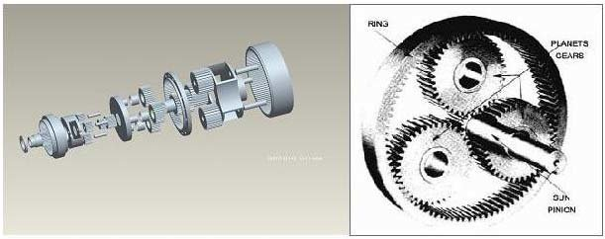

Figure : three- stage planetary gearbox [1].

The connection from the motor to the gearbox will be a shaft coupling, with a keyed system, see Figure 6.

Figure : Shaft couplings [2], [3]

The thick split spider on these couplings takes on twice as much torque as standard split spiders, while a set screw holds the hubs in place on your shaft. Also known as jaw couplings, use them to connect motors to pumps, mixers, and other high-torque equipment. You don’t need to lubricate them.

For a complete coupling, you’ll need two hubs, one split spider, and a split spider cover hubs attach to the end of your shaft. Split spiders cushion between the two hubs to dampen vibration, reduce shocks, and handle shaft misalignment, extending the life of bearings, seals, and motors. You can replace them without having to remove the hubs or move your shaft and equipment around, which reduces the risk of needing to realign the shaft. Spiders with medium-soft hardness are the most used and are good for applications that start, stop, and reverse often. Those with medium hardness handle higher torque than those with medium-soft hardness, but they don’t reduce vibration as well. Split spider covers hold the spider in place.

### 2.2.3 Soil Removal System

The disturbed soil needs to be removed from the shield after disturbing has been done by the cutter head. The material will come through the cutterhead and due to the rotating nature of the cutterhead will collect on the outsides of the shield. The auger chamber will be positioned to collect soil at the outer rims of the cutterhead and then be carried upwards by an auger. The auger will be around 0.063m in diameter with an enclosure surrounding it. Other options considered were a vacuum system, which would use high pressures and an enclosed system to carry the clays upwards.

This auger system relies on the fast rpm provided by a motor attached to the dynamic platform to transport clay from low to high elevation. The disturbed soil will build up in the bottom chamber of the of the shield, gaining upwards pressure from the continuous adding of soil in the duration of the dig. The spin of the cutterhead directs the clay to the outer diameter inside the shield, guiding it to the auger screw. There is also a catch present at the bottom of the auger shield to centralize the soil in the diameter of the auger. Once the soil is centralized, the rotation of the auger transports the soil upwards. The plan for soil disposal once the transported soil reaches above surface level is to add some sort of slide so that it can be relocated far from the hole so that it will not spill back into what has already been dug.

Figure : Auger Screw for Clay Removal

### Soil Removal Rotation System

For the soil removal rotation system, the system will rotate at a rate of 50 RPM. This was determined by the properties of the clay and by the size of the auger flights which are doing the extraction. The auger flights are 0.06m in radius, distance from the edge of the flight to the internal shaft. This gives the soil a small area to be carried on of around ~0.01m^2. The soil being made predominantly of clay means that it will have a low friction angle, an assumption was made that it likely ranges from around 10 – 20 degrees. This means that the excavated clayey sand will not pile up high and remain on the flights, rather it will form a thinner layer.

$$Area of Annulus = π(R^{2}-r^{2})$$

$$Area of Annulus = π({0.06}^{2}-{0.006}^{2})$$

It was assumed that due to the sand content in the soil it is likely that it would have a friction angle of ~15 degrees and that due to the centripetal force being applied to the soil within the auger the soil would form a cone like shape around the outside of the cylinder. Therefore, with an angle of 15 degrees a radius of 0.06m the height of the projected soil layer which could be excavated by the auger is 0.016m. The volume of the corresponding cone for one revolution (0.01m^2 area) would be 6.03*10^-5 m^3.

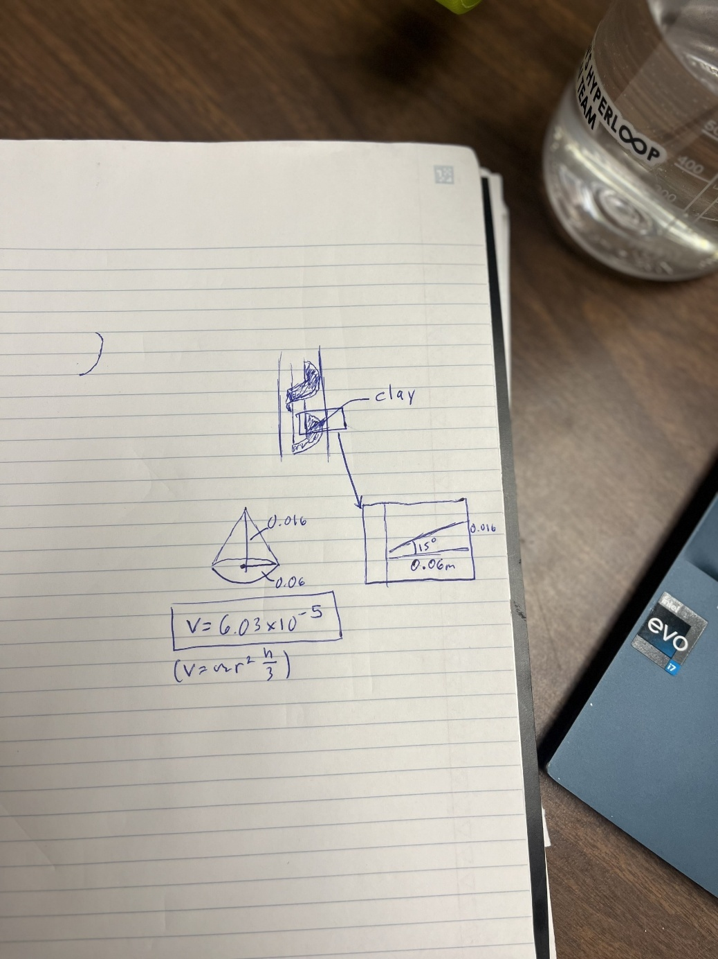

Figure : Calculation for the basis of the clay

From the cutterhead calculations which project that 3*10^-3 m^3 of material will be moved each minute, the auger must spin at around ~60 rpm.

Table : Cutterhead extraction calculations

|  |  |
| --- | --- |
| Volume (m^3) | |
| Volume of auger (m^3) | 2.00E-03 |
| Volume of surrounding cylinder (m^3) | 1.49E-02 |
| Max volume of cuttings (M^3) | 1.29E-02 |
| Weight of max amount of cuttings (kg) | 34.96 |
| Projected amount of material to be moved each rev (m^3) | 6.03E-05 |
| Amount needed to be excavated each minute (m^3) | 3.75E-03 |
| Rpms needed | 62.19 |

#### 2.2.4.1 Motor

Based on the Calculation for the Power required for the Removal System (see section 2.2.6) the max power draw being seen is 210.36 W (0.28 HP), and with a factor of safety of 1.5, a power draw of 315.54W (0.42HP). Based on these values, the 120 VAC power supply can be used to power this motor, and a 0.5 HP motor will be used. The projected motor to be used is Marathon X029, which is a single phase 0.5 HP motor with a rated motor speed of 1075 RPM. Combined with a proper gearbox the motor, can achieve the desired RPM, while meeting the torque requirements of the system.

The motor has a standard 48Y Frame, with overall length of 10.84”, base plate width of 5.62” and a shaft diameter of 0.5”, weighing 22 lbs. The Motor Schematic can be seen in Figure 6below.

Figure : Engineering Drawing of the Marathon X029

#### 2.2.4.2 Gear box

Due to space issues at the top of the shield the auger gearbox will be designed with a 90-degree rotation and utilize a bevel or a worm gearbox design. The augers small size means it must have a higher RPM than the cutter head to effectively remove all soil which is entering into the machine. The predicted rpms for the auger are ~60 rpm, with a max torque needed of ~32. The auger motor has a speed of 1075 rpm which means the gearbox must have a gear ratio around ~18:1. The worm may be the best option for the team as it has the capacity to make large reductions to shaft speed while transmitting motion at a right angle.

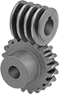

Figure : Worm and worm gears

The gearbox will be attached to the motor with the same couplings as used for the cutterhead and seen in Figure 7. While the output of gearbox will be fastened to the auger shaft.

### Shield and Support

A rudimentary structural analysis of two scenarios, one using a cross-bracing and another using no cross-bracing were investigated. In both scenarios, 200 GPA steel and a 3 mm cross-section were used. The half-shape was used to simplify the analysis because of the symmetrical shape of the circular shield, using a pin and roller as a support. In scenario one, no internal bracings were used. In scenario two, five 20 mm x 20 mm 200 GPA steel cross sections were used to reinforce the internal shape. These bracings proved to improve the distribution of forces within the shield structure. From this analysis, it could be inferred that the implementation of diagonal braces within the shield could prove to be useful for reducing deflections, caused by the soil pressure inward around the tunnel boring machine. The figures are shown below. The uniform distributed load representing the soil pressure was 200 kPa inward from all directions. This pressure is not typical of 1 m depths. Figures representing these scenarios are shown below.

Bending Moment with bracing (kN m)

Joint displacement with bracing (m)

Joint displacement with bracing (m)

Bending Moment without bracing (kN m)

Joint displacement without bracing (m)

Joint displacement without bracing (m)

### Protection around machine

### The current plan for protection around the machine is to encase the frame with Lexan, as it is an industry standard for encasing dynamic components to ensure operator safety. This is key to protect the surrounding area since dirt, stones, and other objects could be projected outside of the area in which the digging machine operates in. Encasing the frame with Lexan would ensure that the operator of the digging machine can still see into the system, as Lexan is a transparent carbon polymer. Full view of the machine is critical to maintain operability of the machine, and for an emergency stop to be activated if a the operator spots anything wrong with the machine.Drill Lift System

The initial plan for the lift system was to use four gear-driven linear actuators on 4 sides of the frame, as seen in Figure 12.

Figure : Frame of Digging Machine with Linear Actuators at all four corners

Due to cost constraints, as one of these actuators costs upwards of $3000, it can be stated that using this model of actuator is not ideal. Additionally, the team has decided not to go with this option since it has minimal transferability to the full-sized TBM. Currently, we are exploring more options for the lift system to adapt for the size and weight constraints that this design poses.

In our new design, it was mentioned that the aid of onsite vehicles can be used in the dig. A new proposal involves swapping out the linear actuators for Igus Drylin linear guides, seen in Figure 13, where the middle dynamic platform in Figure 12 is able to slide freely.

Figure : Igus Drylin Linear Guide

This replacement is significantly more budget friendly and uses onsite technology so that the design is less complex. The current frame must be adapted so that the dynamic platform can be lifting up and down with the help of a forklift. It is assumed that a forklift will be able to lift the full weight of the dynamic platform, plus all of the components that are underneath it. It can be assumed that the forklift does not need to exert force on the platform when digging, but only when the dig is complete to bring it back to the top of its stroke. This assumption entails the digging machine being able to move downwards under its own weight. If necessary, the forklift could exert additional force downwards on thee platform if needed, but risks damaging the digging machine and subcomponents in the process.

### 2.2.8 Power System

There are three systems within the machine that will receive power, each receiving power from different sources.

#### 2.2.8.1 Cutter Head Motor System

First the cutterhead will be using the 3-phase power connecting to the 480V. The power was found by first taking the stress failure of the rock and calculating the amount of force required to break the ground given the contact area of the drill, using that force, the size of the cutter head and the RPM of the cutterhead, the max required power of 12.88 kW was calculated. See Figure 10 below for the calculations.

Figure : Power Calculations for the cutter head system

#### 2.2.8.2 Soil Removal Motor System

To calculate the auger power, the weight from the auger itself and the weight of the cutting were found and used to calculate the force and taking the radius of the auger, the torque was found and taking that with the desired RPM (62), the power was calculated and found to be 210.3 W (0.28 HP). This being much lower, this system will be connected to the 120VAC single phase portion of the generator. The calculations can be seen in Figure 11 below.

Figure : Power Calculations for the auger system

#### 2.2.8.3 Raspberry Pi System

The max power consumption of the Raspberry Pi was taken using the value of 5 Volts DC supply to the board. The board has a max of 3 amps running through it, making the power consumption being 15W. To isolate the electric system from the motors as well as the power being so much lower, a separate battery pack will be used to power this system.

### 2.2.9 Software System

The VBM will have a software system to enable monitoring and control of the system. Traditionally TBMS are outfitted with a fully integrated digital control system, with several automatic fault warnings and redundancy Civil Excavations. The QHDT software system has been designed in accordance with the requirements set by the boring company and informed by industry practices. The software system will consist of using Tkinter library for the fronted, this will then interact with the backend via calls to specific endpoints.

#### 2.2.9.1 Frontend

The system will include a software graphical user interface on the front-end, which will contain essential control and performance indicators. To implement the GUI, Tkinter, an open-source portable graphical user interface library will be leveraged. The primary components of the front-end will include, an emergency stop button, status portions, and different telemetry metrics with real time updates.

Table 4: Frontend Component Breakdown and Functions

|  |  |
| --- | --- |
| Component | Description/function |
| Emergency stop button | * Button will stop all operations at once * Button widget will need to be utilized * Backend logic triggered via ‘command’ |
| Machine Status indicator | * Representation of the machines operation state * Via Label widget |
| Telemetry metrics (real time) | * Cutter head speed (RPM) * Distance traveled * Time for penetration * Via ttk.progressbar |

To ensure the machine gets real time updates, command ‘after()’, will be used.

#### 2.1.9.2 Backend

The backend for the VBM and the GUI will consist of different endpoints that have JSON data. JSON is an open standard file format and data interchange format that uses human-readable test to store and transmit data objects consisting of name-value pairs and arrays. This is commonly used to data format with uses in electronic data interchange, which includes that of web applications with servers. The endpoint will be a specific location where an API sends requests for information and receives responses. These endpoints will handle tasks like real time telemetry updates and executing control commands, ensuring the system responds dynamically to user input and live data.

The API which will be used for this project will be FastAPI, which will enable the real-time telemetry and control responses which the machine needs. This was chosen due to its real-time data handling and asynchronous programming which is needed for the VBM. It also includes built-in features such as WebSockets for low-latency communication. Asynchronous programming, out of the box, can be done which will allow for efficient handling of multiple simultaneous connections, important for this use case because real time communication is needed. Data is also automatically verified, which should produce accurate and reduced errors. As well, FastAPI is built on python, so it will enable the team to continue using python.

## 2.4 Digging Machine Parameters

The much extraction system is the limiting factor for the digging machine. As it is projected to move, around 12 times less material per revolution than the cutterhead is. This means that it must have 12 times the rpms that the cutterhead has, although to achieve the needed torque the rpms must remain under ~70 rpm for it to be able to deal with the max number of cuttings it could handle. Due to this, even if the cutterhead could be optimized to extract more material or for higher rpms, it would not be able to exceed the material the auger is able to remove at 70 revolutions per minute. This is also a max case, which the team is not comfortable in assuming would hold up before testing has been done.

Due to this the team has projected that the auger will run at 62 rpms, extracting 3.75*10^-3 m^3 per minute. In total the auger would have to move 0.2 m^3 of material which would result in a tunnelling time for the whole system at ~53 minutes.

$$Tunneling time for muck extraction auger=\frac{\left(total material to excavate\right)}{projected amount of material that can be excavated each minute }$$

$$Tunneling time for muck extraction auger=\frac{0.2m^3}{3.75*{10}^{-3}m^{3} }$$

$$Tunneling time for muck extraction auger=53 minutes$$

# 3. High level Design calculations of your machine. At a minimum, this should include:

## 3.1. Machine Structural Analysis

### 3.1.1. Digging machine itself

From output torque calculations from section 2.2.6, it can be stated that the maximum torque exerted by the driven gear on the shaft of the cutterhead is $τ=24.6 KNm$. The cutterhead model can be simplified to a model of a hollow shaft and solid disk, both made of Steel Alloy. The type of material for this cutterhead is still undetermined, but Steel Alloy looks like it resisted torsional loads the best.

Figure : Simplification of Custom Cutterhead CAD

It is assumed that the torsional load is applied to the top of the figure, where the cylindrical shaft appears the separate. To account for the maximum torque is applied to the cutterhead, it is assumed that the torque is applied to the very end of the shaft, at the top.

Failure mode would be described as any point throughout the system where the maximum yield strength is reached, resulting in inelastic plastic deformation. To ensure this does not occur, correct assumptions need ot be made regarding the simplified system. It can be assumed that an overestimated applied torque on the shaft of the cutter head occurs when the disk is static, but the full torque is applied. This is considered an overestimate since the cutter head will rotate with slipping when digging.

The factor of safety for this application must be assumed to be over 1.5 to be considered safe. The conditions in which the factor of safety are calculated are using the maximum torque over the torque applied, as seen in this equation:

$$FoS=\frac{τ_{Yield}}{τ_{Applied}}=\frac{σ_{y,vM}}{σ_{vM}}$$

SolidWorks FEA torsional load was performed on this simplified model to get a maximum Von Mises of $218.857 MPa$, as seen in Figure 19. When comparing this to the yield strength of $620.422 MPa$, we can plug it into our FoS equation.

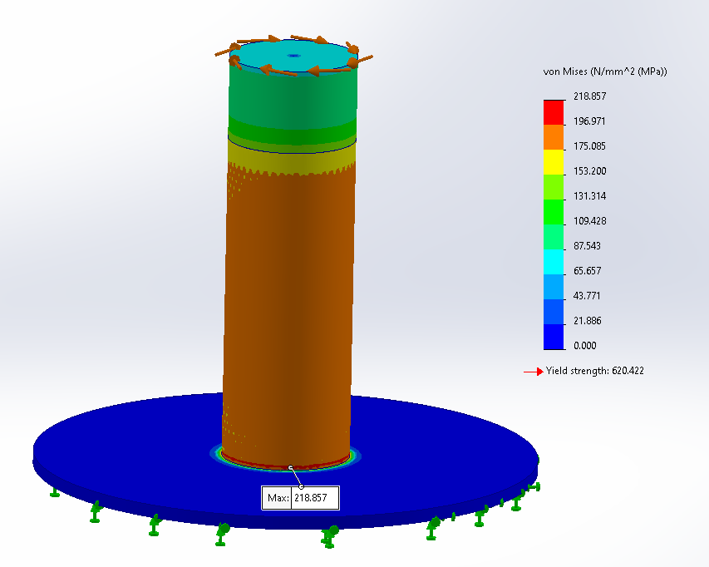

Figure : Torsion Load FEA, showing max Von Mises of 219 MPa

$$FoS=\frac{σ_{y,vM}}{σ_{vM}}=\frac{620.422}{218.857}=2.83$$

The factor of safety (FoS) for this torsion load applied is 2.83, which greatly exceeds the minimum of 1.5. It should be stated that the maximum stress can be found near the connect to the disk. This is expected, as the point of interest is furthest away from the exerted torque. Welds and screw connections between these two bodies need to be carefully considered to minimize the internal stress in this area.

### 3.1.2. Launch and/or supporting structures

The frame is a critical point to analyse in terms of its strength during the duration of the dig. The first thing to consider is the supporting the weight of the digging machine during the runtime, as the torque from the spinning of the cutter head will generate a force on the frame.

Figure : Top View of the Dynamic Platform and Frame and Forces and Moments present

The force acting on the frame from the moment can be modeled in SolidWorks via FEA static deformity simulation. The moment generated can be given by the maximum torque based off of the geometry of the dynamic platform. The force can be calculated based off of the moment and divided among the 4 beams. Yield stress is calculated from the FEA analysis in SolidWorks, and then compared with the Von Mises deformity to find the factor of safety.

Similarly, the structure of the dynamic platform must be analysed to ensure that it can withstand the moment generated from the torque of the motor. One key consideration for this analysis is how the dynamic platform interacts with the support geometry. The support geometry will oppose the moment generated, giving the welded members a mechanical advantage for the direction of rotation. Yield stress is calculated from the FEA analysis in SolidWorks, and then compared with the Von Mises deformity to find the factor of safety.

It is important for when these bodies are analysed that they achieve a factor of safety of over 1.5 to ensure the structure will stay in tact.

## 3.2. Control System - Hardware

The VBM will have an electrical system that will be used to monitor and react to the output of multiple facets of the machine during the drilling process. The major measurements that will be measured will be Rotation systems speed (RPM), system torque on each of the motorized subsystems, and depth drilled (used also to determine linear speed and drilling time for 5mm penetration).

### 3.2.1 Sensor list and location map

To not only operate the motors safely, sensors and components are used to monitor aspects of the system and the control the potentially hazardous components (such as the motors). To do this, there are three major categories of the electronics that everything can be broken down to.

First is the power supply and motor control for the two motors of the system. This includes the connections of the generator and the motor, as well as everything in-between. In this includes two motor relays that are in the middle of the lines that control whether current goes through to the motors. In addition, there is potential to add variable frequency drivers (VFDs) for each motor to control the frequency and therefore the RPM and torque output that the motors output.

Next is the telemetry and sensors which are used to monitor the systems key areas including the RPMs of the two subsystems, the torque output from the motor, depth drilled, drill speed, drilling time for 5mm penetration.

For the RPM monitoring the plan is to use Hall effect sensors, mounting them near the desired rotors. They will work by mounting magnets into the motor and as it rotates once the magnets get close to the censor, it will return a high signal to the system, being so slow, the system will use multiple magnets equidistant from one another and looking at the time between the high signals to determine the RPM.

For the torque each motor will have a current sensor, monitoring the current going to the motor. This will be used to see how much power the motor is needing to get the required torque from the cutterhead. Higher current means more torque. Figure 14 below shows the spec of the 20HP motor showing the different load percentages and their respective currents. Using these values, a correlation between current and torque can be found, monitoring the torque on each motor.

Figure : Spec of the 20HP motor showing how current and torque are related

For the Depth drilled, linear speed, and drilling time for 5mm penetration, an ultrasonic sensor can be used placing it at the top of the machine shooting a pulse at the ground and reflecting it back to the sensor to see how far it is from the ground. At the beginning a reference point will be set, and every measurement after will be compared to this reference point to see the depth drilled, and previous values will be used to figure out the speed at which the machine is going and how long it took to break the last 5mm of ground.

The last section of the electronics is the control system, which consists of the Raspberry Pi 4 as well as the analog to digital converter, which allows all the analog based sensors, (current sensors) to be converted to digital values so the Raspberry Pi can properly monitor the values. This section is what brings all the other components together.

In terms of where everything is located. The Hall effect sensors will be placed near the rotation systems to accurately determine the rate of rotation, with the magnets being mounted on to the rotors. The Ultrasonic sensor will be mounted on the outside edge of the machine, facing towards the ground, allowing to trigger and recover the ultrasonic pulse to measure the distance from the ground. All the other electronic components will be located within the stack, which will be designed to mount each of the other components into place and will be mounted to the top of the VBP for safe and reliable control of the system. A high-level list can be seen in Table 5 below as well as a high-level sensor location map in Figure 15.

Table :Sensor List

|  |  |
| --- | --- |
| Metrics | Sensor/Component |
| Auger RPM | Hall Effect Sensor |
| Cutter Head RPM | Hall Effect Sensor |
| - | Analog to Digital Converter |
| Auger Motor Torque | Current Sensor (ACS 712) |
| Cutter Head Motor Torque | Current Sensor (ACS72981LLRATR-050B3) |
| Depth Drilled, Linear Speed and drilling time for 5mm penetration | Ultrasonic sensor |
| Auger Motor Relay | 1 Channel Relay |
| Cutter Head Motor Relay | 3 Phase Solid State Relay DC to AC |

Figure : High Level Sensor Location Map, all electronics not explicitly shown on the drawing will be located in the stack

### 3.2.2 Control Unit

For the entire system, the main control unit being used is a Raspberry PI 4 board. Everything electrical on the machine will run through this Raspberry Pi 4 each of the sensors bringing the data through the Pi to be processed and the outputs being the GUI and the input into the transistors that control the relays for the motors.

Being one main processor, everything is connected to the Pi and communicates through the Pi. The high-level overview of the system is that the sensors collect and monitor the relevant data on a clock that is universal between all the sensors, and this is configured to be displayed onto the GUI. At the same time internal restrictions will be set on the system like safe ranges for torque, speed, rate of rotation, and anything out of these “safe zones” will trigger the system to shut down and stop the system. To turn on and off the system, relays for each motor line are integrated into the main connections between the generator and the motor. The relays are normally open and to close the connection, an input voltage from the Pi will be needed to do so. With that a transistor will be on the input line that determines whether the voltage goes through to the relay. If the input is on, then the +5V will continue through to the relay closing the motor connection. If something was to go wrong or the Pi was to lose power or connection, the power will be seized, opening the relays once again.

### 3.2.3 Electronic Schematic

The electrical schematic can be seen in Figure 17 below, for reference to the Raspberry Pi pin layout, see Figure 16. On the schematic all +5V lines are in dark blue, +3V lines in light blue, and ground connections are in green. All else are input and output lines other than the motor power lines which are the labelled red lines. This will be the outline for building the electronics and the overall design of the control system. If VFDs are ultimately decided to be used, they will be implemented in the projected boxes seen in the schematic.

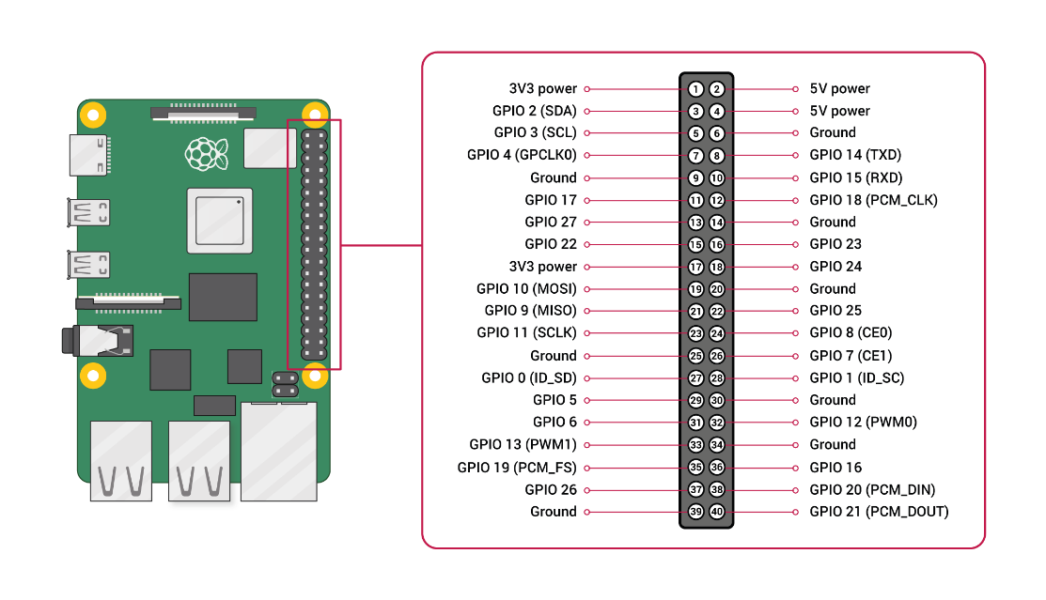

Figure : Raspberry Pi Pin Layout Reference

Figure : Electrical Schematic of the Control System Hardware along with the power supply to the motor.

## 3.3. Control Systems - Software

The frontend and backend will be written in python and use the Tkinter library for implementing the front and backend.

### 3.3.1 Frontend

Option 1: Simple TkinterGUI (very simple MVP)

Figure 29: Potential Layout of the GUI. Note Not all contents on figure are expected to be on final GUI, only a prototype.

**Example for implementation:**

import requests

# Function to fetch telemetry data

def fetch_telemetry():

    try:

        response = requests.get("http://localhost:5000/telemetry")

        data = response.json()

        # Update progress bars

        thrust_bar["value"] = data["downward_thrust"]

        speed_bar["value"] = data["cutterhead_speed"]

        # Update status

        if data["status"] == "Good":

            status_label.config(text="Status: Good", bg="green")

        else:

            status_label.config(text="Status: Critical", bg="red")

    except requests.exceptions.RequestException as e:

        print(f"Error fetching data: {e}")

    # Schedule next update

    root.after(1000, fetch_telemetry)

# Start fetching data

root.after(1000, fetch_telemetry)

Figure 30: Code snippet for implementing front end.

### 3.3.2 Backend

The backend of the system will mostly comprise of all the sensor software of the control system, including the power controlling the relay, as well as running the emergency stop button through the GUI to the hardware of the system. With the relay system that is used, once the power from the relay is stopped, the circuit will be open, and the motor will stop. The Pi also has its own power supply and once this power connection for the motor is broken, the Pi will continue to run, giving the ability to restart the system and continue if necessary.

All of this will be coded through Python, and it will have a structured modular philosophy. The general plan is to have a standardized clock that loops through the code continuously collecting the data from each sensor at that given time interval. Depending on the sensor it will be compared to the last value from the previous loop or directly moved over to the GUI depending on what is being measured. For each measured value there will be a safe, caution, and danger zone. The code will classify each collected value and compare it to this, and it will be reflected on the GUI. If the values break a certain threshold, the system will flip on the emergency shutoff and shutdown the motors to follow safety protocol. From a backend point of view, this will look like putting the two dedicated pins to the relays output to low, removing the signal powering the relay, opening the circuit. Also, if the emergency stop button is ever pressed these pins will be set to low as well. A simple code will allow for easy iterations and debugging during the creation process of the software development process, while still meeting the requirements of the system.

Another potential idea for the safety interlock, with the sensor values going out of range, is in the case of a faulty sensor, if the faulty sensor is giving a faulty reading and falling out of range, a pop-up can appear on the GUI that will give the operator the option to ignore the potential shutdown, this will then disregard the sensor reading for the duration of the dig if chosen to ignore. If not chosen to ignore or not responded by the operator after a given amount of time, the safety system will continue with the shutdown procedure. For a better understanding of the safety interlock methodology, see Figure 22 in section 4 of the report.

## 3.4 Estimated thermal output

The primary components where thermal output is a consideration include, the motor for the cutterhead and the motor for the auger screw. There will also be a small consideration for telemetry system which will be powered by a small battery. The optimal (steady state) temperatures for the motors is 40 degrees, the battery is lithium ion and has an optimal range of 15 to 35 degrees. It also has battery protection technology to support over charge/discharge protection and over heating protection. Based off gearbox efficiency, what doesn’t go into moving the components will go into thermal output.

### 3.4.1 By subsystem

Table : Thermal Output Breakdown

|  |  |  |  |  |  |  |  |  |
| --- | --- | --- | --- | --- | --- | --- | --- | --- |
| Metrics | Hp | Output power (kW) | Voltage (V) | Current (ohms) | Ambient temp (degrees) | Rise Temperature (from manufacturer) | Max resistance R = V/I | Max projected torque |
| Cutterhead motor | 20 | 15 | 230, 460 | 56-52/26 | 40 | 75 | 4,115 | 34.6 kn*m |
| Auger motor | 1/2 | 0.37 | 115V,230V | 6.4/3.2 | 40 | N/A | 36 | 32.4 Kn*m |
| Telemetry battery | N/A | N/A | 5 | Output 3,2 |  | N/A | 1.7 |  |

# 4. Safety Interlock Mechanism Flow Chart

Figure : Safety Interlock Mechanism Flow Chart. See section 3.5 for details on the functionality and implementation of the safety interlock system.

# 5. Equipment lifting and transportation structural analysis

## 5.1 Lift Procedure

### Pre Lift

1. Conduct a thorough inspection of the lift area to ensure it is clear of obstacles and hazards.
2. Ensure all members involved in the lift are trained and authorized to perform lifting operations.
3. Members involved must understand the planned lift procedure and goal of the operation.
4. Ensure all members involved in the left are wearing personal protective equipment (PPE) including gloves and steel toed boots.

### Lift Team

1. Roles are assigned to each member of the lift team, including a lift coordinator, spotters, and operators.
2. The lift coordinator is responsible for overseeing the entire lift operation and ensuring adherence to the lift procedure.
3. Spotters are positioned strategically to monitor the lift and provide guidance to the operators.
4. Operators are trained members who perform the lift.

### Lift Procedure

1. Conduct a final safety briefing before initiating the lift, emphasizing key points such as weight limits, hand placement, and emergency procedures.
2. Listen to the lift coordinator for directions during the lift.
3. Lift slowly and steadily, avoiding sudden movements or jerks that could destabilize the load.
4. The lift is not done until the lift coordinator gives an all-clear confirming members have successfully completed the lift.
5. The lift coordinator should be monitoring the lift closely and be prepared to stop and assess if any issues arise during the operation.
6. All lift members should have proper form as shown in Figure 1 by bending your knees and lifting with your leg muscles, your spin should not be angled further then 45 degrees.

Figure : Proper lifting procedures

### 5.1.1Emergency Lift Procedure

1. At any point during the left a member of the lift team or lift coordinator can initiate the emergency plan.
2. All members should follow the instructions of the lift coordinator during an emergency.
3. The lift members should slowly put down the object and continue to stay calm.
4. The emergency stop procedure does not end until an all clear is given by the lift coordinator.
5. In case of injury emergency services should be called depending on the severity.

## 5.2 Lift Procedure for Competition

The VBMs largest component the frame has dimensions of 0.6 m x .6m x 1.3m and will weigh ~800 pounds or 362 kg in total.

On the day of the competition the team will take the following steps

1. Have members dig a small pit around 0.2m deep
2. Utilize site infrastructure provided by the competition (e.g. forklift)
3. If lifting needs to be done have members follow proper lifting procedures.
4. Have members attach shield into the frame and attach to the rail system, with proper lifting procedures
5. Remove members from the general vicinity

## 5.3 Transportation Plan and Analysis

Predicted loads

Important: all lifting points need to be marked, including allowable force

### Plan A: Mid-Size SUV Transportation

The VBM will be dissembled, and all the parts will be packed into heavily padded wooden boxes. The QHDT team will rent a 2023 Ford Escape from Enterprise car rentals. The backseats of the vehicle will be laid down and the boxes will be secured into the vehicle’s cargo space. The 2023 Ford Escape’s cargo dimensions and capacity are the following:

**Cargo volume with backseats down:** 65.4 cubic feet (1.85 cubic meters)

**Cargo space with backseats down dimensions (length x width x height):** 5.71 ft x 4.78 ft x 2.9 ft (1.74 meters x 1.46 meters x 0.88 meters)

**Rear opening dimensions (width x height):** 3.51 ft x 2.53 ft (1.07 meters x 0.77 meters)

**Maximum payload capacity:** 2,356 lbs

As the VBM’s total dimensions and weight fall below the vehicle’s maximum carrying capacity, the vehicle will be able to safely transport the machine to and from the competition.

The 2023 Ford Escape has cargo hooks in the interior of the cargo space. Cargo nets, bungee cords, and ropes will be used to secure the boxes in the rear of the vehicle by tying them down to the cargo hooks.

This plan is the ideal transportation scenario for the VBM to and from competition.

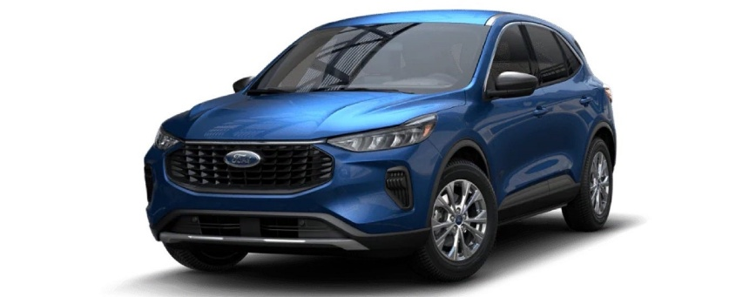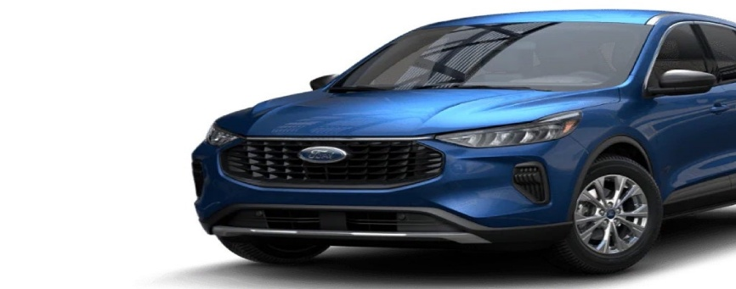

Figure : Cargo hooks in the cargo space of the 2023 Ford Escape.

Figure 34: Cargo hooks in the cargo space of the 2023 Ford Escape.

Figure 35: Cargo hooks in the cargo space of the 2023 Ford Escape.



Figure : 2023 Ford Escape to be rented for transportation.

### Plan BBBBBBBBA: FedEx Land Freight by Truck

In the case that the 2023 Ford Escape or similar mid-size SUV cannot be rented by the QHDT team, the VBM will be land freighted by FedEx Freight Shipping Services. The team will dissemble the machine and pack it into a wooden crate to be shipped by FedEx via Less Than Truckload (LTL) Freight shipping from Kingston, Ontario, Canada to Bastrop, Texas, USA.

The quoted freight details are as following:

**Estimated shipping time:** 5 business days

**Estimated cost:** $3,000 CAD each way.

Given the 5-day lead time, QHDT will pack and ship the VBM by no later than March 17, 2025, to ensure the machine is at NABC 2025 for the competition’s May 23, 2025 start date. Following the competition’s conclusion, the VBM will be repackaged into the crate and LTL freighted back to Kingston, Canada from Bastrop, USA via the same FedEx service.

Figure : Projected FedEx LTL Freight transportation timeline.

## 5.4 Transportation load analysis

Forces to consider during transport

Static forces

* Weight of the cargo, or the VBM and its components, including the packaging.
* This will be around 800 pounds, the potential for a ~20-50 pound packaging

Dynamic Forces

* Forces due to acceleration, deceleration and vibration need to be considered during transportation. Will be expressed as multiples of gravity.

### Road Transportation

The general loads which will be experienced for during transportation will be from

* Braking and acceleration, (Longitudinal)
  + This type of acceleration is typically around 0.5g to 1.0g
* Lateral Forces, such as during corning or lane changes
  + Acceleration around 0.3g to 0.5g
* Vertical Vibrations
  + Accelerations around 0.2g to 0.5g

Modelling should include combined cases, where braking, corning and vibrations are all considered to simulate realistic conditions. Such as:

* 0.6g longitudinal, 0.2g lateral and 0.2g vertical all together.

### Securing machine

For Plan A the team will drive the VBM to Texas in a car, with it packaged and secured in the back. This analysis is provided that the team goes with this option. If this option is not feasible, the team will send the VBM with Fedex who will be responsible for securing the load.

How the machine will be secured packed into a wooden crate, crate will be secured with a heavy duty cargo net, bungee cords, ropes, heavy duty rachet straps with the ability to secure items <1000 pounds.

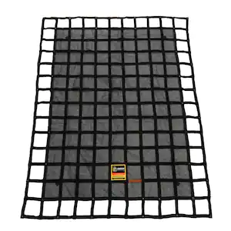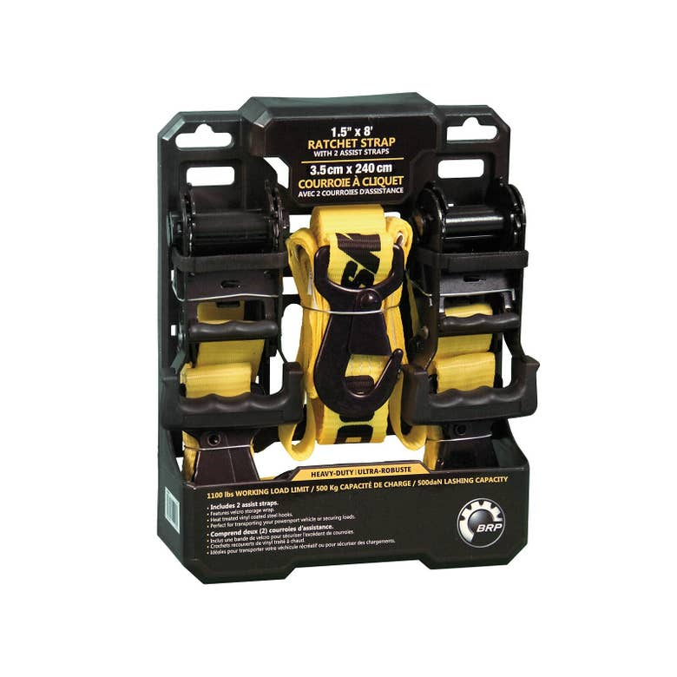

Figure : Examples of items used for securing the VBM in the back of the car [4], [5],

### First principles calculation for safety factor

Modelled for a crash scenario going at 70 mph (average highway speed in the US).

Time to stop is 0.5s

Stopping distance = 1m

Real world crashes often have accelerations of 20g to 50g.

Item = 800 pounds

$$a=35 x 9.8=343 m/s^{2}$$

$$FoS=\frac{Resisting Forces}{Driving forces}$$

The plan for the factor of safety calculation is to do a structural deformation FEA static analysis to determine whether the structure will deform under the conditions of a collision in transportation. It can be assumed that the frame is ratcheted down to the vehicle in transportation. It can be assumed that the ratchets will not fail in the scenario of a crash. The crash will create a rapid deceleration, creating a reactionary force exerted from the ratchet. This reactionary force can be modelled in SolidWorks via FEA static analysis to get the maximum Von Mises stress. The yield Von Mises stress is calculated from the FEA analysis in SolidWorks, and then compared with the Von Mises deformity to find the factor of safety. It is important that the factor of safety must be above 1.5.

$$Driving force=124,509 N$$

For an FoS of 1.5 a resisting force of 187 Kn is needed.

$Resisting forces=124,509*1.5=186,763$ N

This is an extreme case.

d. FEA analysis for safety factor

# 6. Subsystem and full machine functional test program before arrival for competition week

## Test Procedures for High Voltage scenarios

1. All members of the test must have proper PPE including high voltage gloves, safety glasses and steel toed boots.
2. Ensure all bolts are tight and secured before starting the test.
3. All contacts must be insulated either inside an encloser, heat shrink or electrical tape.
4. Turn on low voltage power to control systems and ESC.
5. Ensure contactors are turned off, the HV power light should be off.
6. Remove battery from kevlar bag then mount battery ensuring BMS is active, plug in manual disconnect.
7. Activate Low side contactors.
8. Activate pre charge circuit of ESC capacitors.
9. After capacitors are charged activate High side contactors.
10. System is ready and live, test can be performed.
11. Once test is done perform power off procedure.
12. Turn off all contactors.
13. Disconnect battery using manual disconnect.
14. Remove battery and put it back in the kevlar bag.
15. Turn off low voltage power.

## 6.1 VBM Testing Procedures

Before any tests members of the test must have proper PPE including high voltage gloves, safety glasses and steel toed boots.

Tests have been planned for essential components of the design including

### 6.1.1 Rotating of cutterhead (with clay)

**Cutterhead Performance Test**

**Objective**: Assess the cutterhead's efficiency in drilling through specified soil or rock types.

**Procedure**:

* 1. Select representative ground conditions (e.g., clay, sand, or rock).
  2. Operate the machine at standard RPM and advance rate.
  3. Measure penetration rate (m/min) and cutterhead wear after the operation.

**Pass Criteria**: The penetration rate must meet the design specifications, and cutterhead wear must not exceed acceptable limits.

### 6.1.2 Auger rotation testing (with clay)

**Auger effectiveness test for removing muck material**

**Objective**: Validate the effectiveness of disturbed clay removal during drilling.

**Procedure**:

* 1. Operate the machine while drilling in wet conditions or with significant spoil production.
  2. Measure the time and efficiency of the removal process.
  3. Inspect for blockages or material buildup on the cutterhead.

**Pass Criteria**: Removal systems must maintain consistent operation without clogging.

### 6.1.3 Structural testing

**Structural Integrity and Vibration Test**

**Objective:** Evaluate the structural soundness and vibration levels during operation.

**Procedure:**

* 1. Drill continuously for a specified duration (e.g., 8 hours).
  2. Measure vibration levels using accelerometers at critical points.
  3. Inspect structural components for signs of stress or damage.

Pass Criteria: Vibration must stay within safe thresholds, and no structural damage should occur.

### 6.1.4 Control and software Testing

**Emergency Shutdown Test**

**Objective**: Ensure safety systems function correctly.

**Procedure**:

* 1. Simulate a fault (e.g., excessive vibration, hydraulic failure).
  2. Activate the emergency stop.
  3. Verify that the machine halts operation immediately.

**Pass Criteria**: Machine must stop within the specified reaction time (e.g., ≤2 seconds).

**Control and Operational Logic Test**

**Objective**: Verify the software's responsiveness, usability, and operational logic.

**Procedure**:

* 1. Navigate the control interface, adjusting parameters (e.g., RPM, thrust force).
  2. Simulate operational scenarios (e.g., hard rock, soft soil) and observe software responses like RPM adjustments or overload halts.
  3. Test conditional logic, emergency stop functionality, and system recovery after simulated faults (e.g., overheating, power loss).

**Pass Criteria**: Commands execute within ≤1 second, operational decisions align with specifications, and recovery is smooth without data loss.

### 6.1.5 Sensor and data testing

**Sensor Integration and Data Management Test**

* **Objective**: Ensure accurate sensor data integration, logging, and reporting.
* **Procedure**:
  1. Connect the software to simulated sensors (torque, RPM, temperature).
  2. Compare displayed readings with input values and introduce noise or faults to test error handling.
  3. Operate the machine to log data, then review logs and generate reports for accuracy and completeness.
* **Pass Criteria**: Sensor readings match inputs within tolerance, errors trigger appropriate alerts, and data logs/reports are accurate and accessible.

## 6.2 Provide all available test results of tests already conducted

No tests have been conducted yet

# 7. Machine Production Timeline and Status

Find below the teams weighted risk matrix which covers high level risk items the team has kept in mind thus far and will continue to.

Table : Team weighted risk matrix

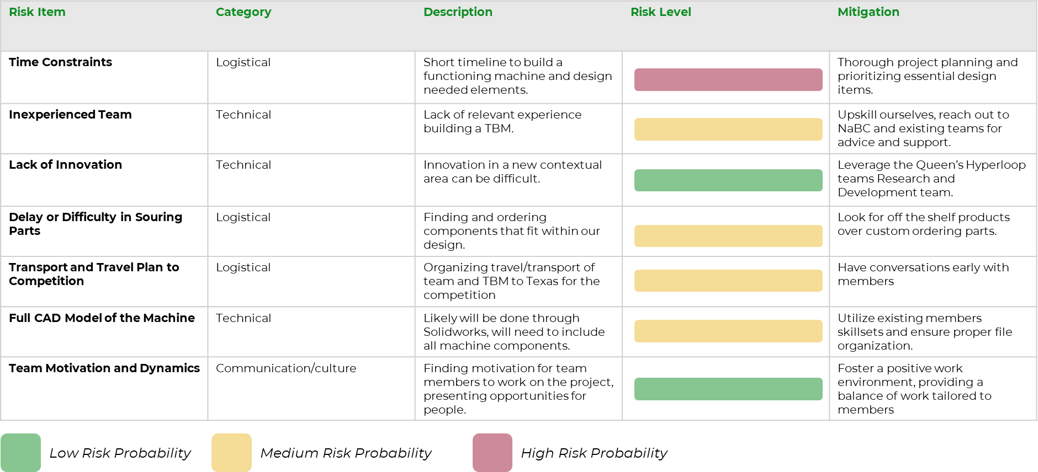

Table : Preliminary design briefing schedule

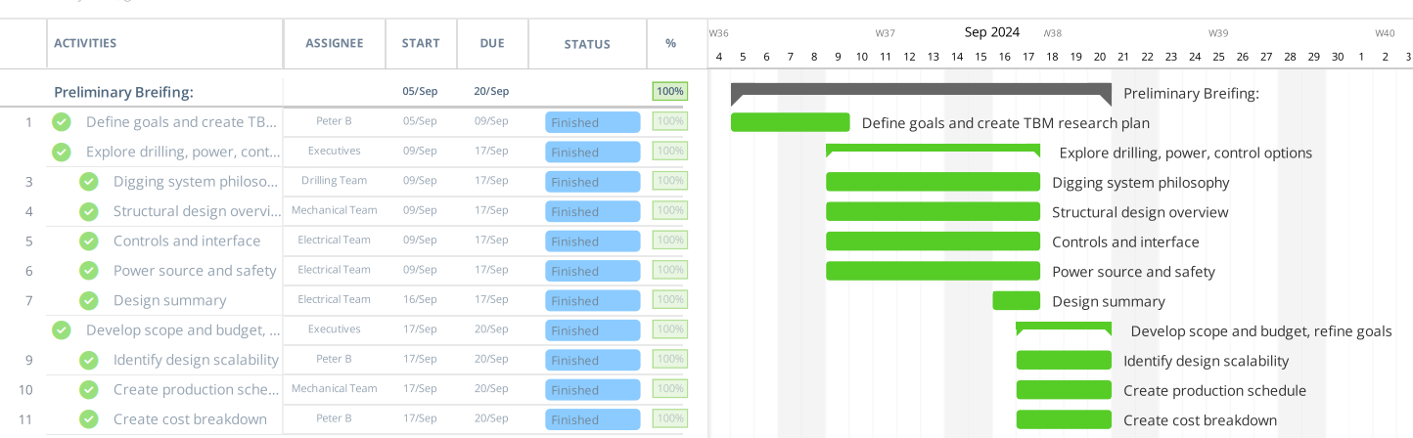

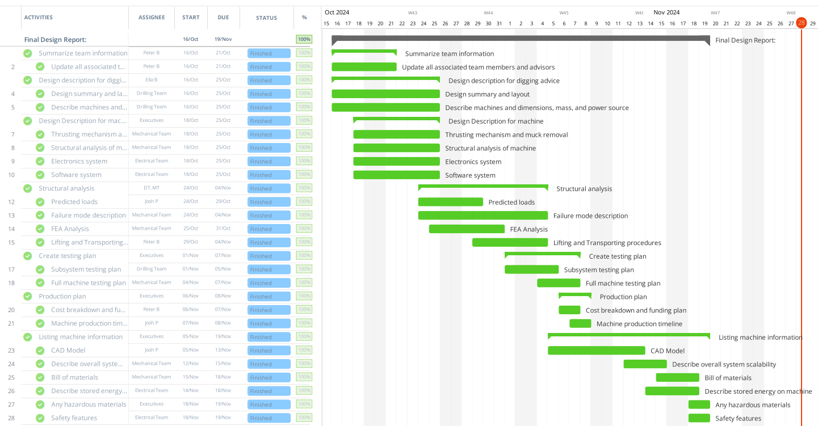

Figure : Final Design Report

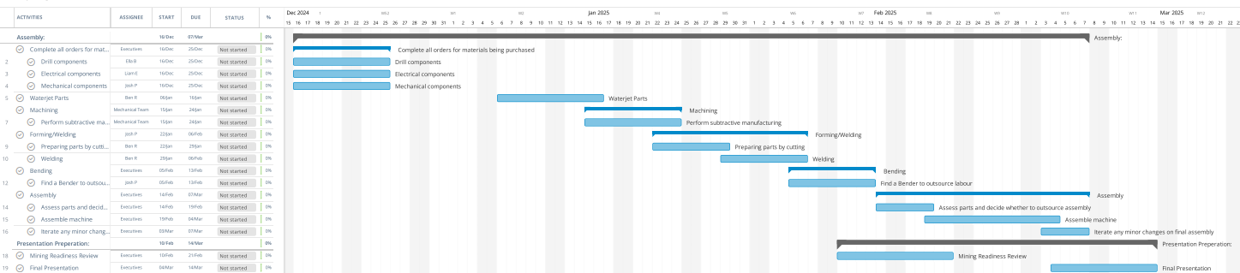

Figure : Assembly and machine production schedule

March 23rd (Sunday) through March 30th (Sunday) competition dates

[Boring_Budget.xlsx](https://queensuca.sharepoint.com/:x:/r/teams/GROUP-QHDTBoring/Shared%20Documents/General/1.Working_Files/Boring_Budget.xlsx?d=w61771e05e14a45f5b45e7ea5b84cc979&csf=1&web=1&e=3FRBMb)

# 8. Machine cost breakdown and funding plan

Co-captains, primarily dean’s donation and industry

The Boring Team will be funded through sources from Queen’s University and corporate sponsors. This includes both the projected machine costs and competition costs of around $13,000. Around $8,000 will go to the team for building the machine, and around $5,000 will go to travel costs and machine shipping costs.

The Queen’s University funding is projected to be around $11,000 and will come primarily from the Dean's Donation Fund, Table 5. This fund is available to all Engineering competitive design teams, outreach programs, conferences, clubs and student-led campus businesses which bring distinction to Smith Engineering at Queen's University. Queens provides this financial support to engineering led initiatives to give them opportunities for teamwork, leadership, project planning, design, marketing and communication skills. Teams may apply once a year for funding, the Hyperloop and Boring team applied for this funding in early November and expects to receive the funding in December.

QHDT also has a large business division who are responsible for procuring corporate funding for the team. The team expects a minimum corporate sponsorship of $2,000 CAD, which will be used primarily to finance the machine costs. The business team plans to take advantage of the number of respected Canadian construction, infrastructure and mining companies which are located and do work in Canada to obtain this funding. The team is currently in funding talks with these companies and will look to secure commitments for funding by January 2025, Table 5.

Table 11: Funding source breakdown

|  |  |  |
| --- | --- | --- |
| Funding Source | Amount | Date Expected |
| Smith Engineering at Queen’s University Dean’s Donation Fund | $11,000 CAD | December 2024 |
| Corporate sponsors | $2,000 CAD | January 2025 |

# 9. List and description of any stored energy on the machine

There will be a battery system onboard the machine for powering the Raspberry Pi and the Telemetry system. The component includes a power supply with two lithium-ion batteries to power a Raspberry Pi, Figure 22. The Battery charge rate is 5V/2A max 7.4V, 2000mAh. This is an off the shelf component with customers using it regularly. The battery will be installed at the top of the VBM drive, and will keep it out of the way of any moving components.

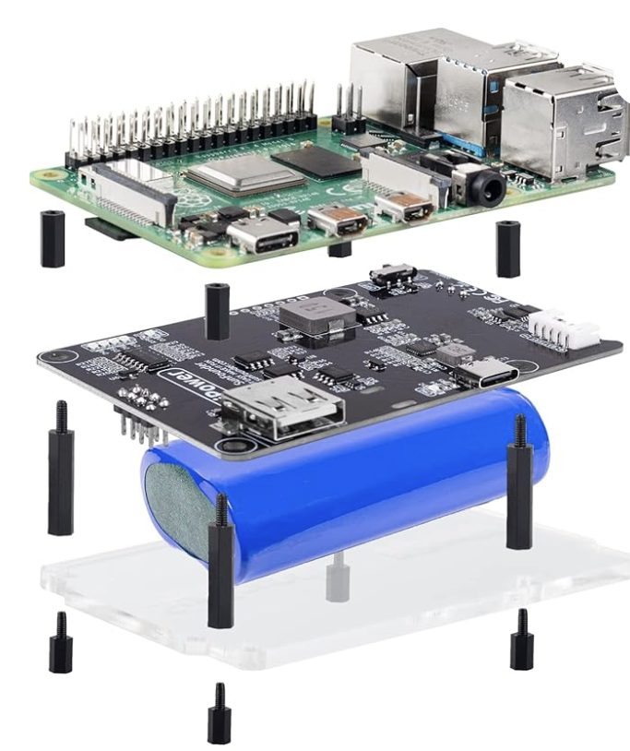

Figure : Raspberry Pi with battery

# 10. Description of safety features including:

Mechanisms to mitigate a complete loss of machine power b. Mechanisms to mitigate leaks, environmental contamination

Single points of failure within the machine d. Include description of failure modes (top 6)

## Safety plan for working

The team did not have any safety issues last year, although new design components are being included this year for which risk identification and mitigation has been outlined here, **Error! Reference source not found.**.

Member safety must always be the top priority during all stages of the design process. The tasks that are required of the Boring team are accompanied by specific risks that must be identified, assessed, and treated or mitigated. A list of risks that this sub-team must plan for can be found in Table 9.

The first risk that Boring team members must consider are general operating and manufacturing risks covering slips, trips, falls and the usage of power tools and hand tools. The construction and adjustment of the Boring drilling machine requires numerous power tools such as drills and hand tools such as wrenches. These tools present a risk of harm such as finger pinching or cuts if used without proper training, PPE such as gloves or CSA approved footwear, and team leadership supervision. Further team rules on power tool safety can be found in Section 7 of the Safety Plan.

The second risk comes from electric shock, working with electrical systems opens up the possibility for members to be injured by electrical currents. The four main types of injuries would be electrocution, electric shock, burns and falls. The drilling process, will likely incorporate the use of water and fluids, which could increase the likelihood of an electric shock event. To mitigate and reduce the likelihood of such an event happening, the team will ground all electronics as well as waterproof essential components.

The third risk is related to respiratory hazards. The primary hazard for the boring team will be from silica dust created when drilling geological material such as clay. This could arise during the testing of the machine. To mitigate this Boring members must wear respirators with the appropriate P100 fine particulate filters when operating the machine for drilling. Another mitigation would be selecting well ventilated environments to operate in. Details on required PPE and best practices for working in the composite room can be found in Section 8 of the Safety Plan.

The fourth risk is related to the potential use of chemicals for the teams drilling process. As the team is exploring options for conditioning the soil to make it easier to excavate. Members working with these chemicals will have to conform to clothing and PPE standards. Further details on the risks of different layup chemicals can be found in Section 8.1 of the Safety Plan.

The fifth risk is related to the operation of the machine, as the drilling machine the team is designing will involve rotating and moving equipment. This creates the potential for a member to be pulled into the machine during operation. Mitigation will include, shields covering the exposed drive shaft, and ensuring that clothing standards and safety standards are followed. It will also be important that the machine has a hard stop wired into it for such a scenario.

The sixth risk is related to burns, as there is potential for the machine components to heat up. This would create the opportunity for a member to encounter a hot surface, resulting in a burn. To mitigate this PPE standard will be followed, proper clothing worn and solvent-resistant gloves.

Table 12:Risk Identification, description, mitigation, occurrence, severity and response

|  |  |  |  |  |
| --- | --- | --- | --- | --- |
| Risk Identification | Description of Risk and Mitigation | Occurrence | Severity | Response |
| out of 5 | out of 5 |
| General Safety Hazards | General safety hazards include slips, trips, and falls, fall of material, operating dangerous machinery, and electrical hazards. In particular, chassis members must be trained and supervised while using power tools. | 2 | 4 | Slips, trips, and falls are to be treated by assessing for head injury, or any sharp pains indicating breaks, strains, or sprains. The individual must seek medical attention for any head related injuries or breaks, strains, and sprains. |
| Electric Shock | Working with electrical systems means there is a risk members could be injured by electrical currents. There are four main types of injuries, electrocution (fatal), electric shock, burns and falls. | 1 | 5 | In the event of an electrical current passing through the body, utilize standard first aid procudures. Shut off all power sources, call 911 if needed. |
|  |
| To mitigate and reduce the chance of this happening the team will ground all electronics by providing a path for fault currents. As well as waterproof enclosures, sealant/coating risky locations. |
| Respiratory Hazards | Working with clays and geologic material, with drilling can release dangerous crystalline silica dust. Silica is harmful when it becomes an airbore dust and individuals breathe in silica dust. Often the damage builds slowly and those affected will have no awareness that the exposure is causing lung issues. | 2 | 4 | In response to airborne silica dust, members will put on face masks, and look to increase ventilation in the area. |
|  |
| Members involved in work with drilling and cutting geologic material will wear half face respirator masks. Members are to review the MSDS before use to ensure the proper respiratory protections are in place. |
|  |
| Members are to test the seal of their respirators before performing any work where respiratory hazards are present. |
| Chemical use | Working with soil conditioning chemicals will have to be aware of any chemical risks that could arise. an example type of chemical would be borax, which is harmful if ingested and can irritate your skin and eyes. Members working with hazardous chemicals may face risk if the chemicals are to contact skin. When working with hazardous chemicals, members are to wear nitrile gloves and lab coats or coveralls, in addition to sealed eye protection. | 1 | 3 | Members exposed to chemical burns are to seek the MSDS for the exposure procedure. If symptoms of exposure persist, the member is to seek medical attention. |
|  |
| Members are to consult the MSDS prior to beginning work. |  |
| Caught in/struck by | Due to the rotating and moving equipment there is potential for members to be pulled into the machine. | 2 | 4 | If members are pulled into the machine, a hard-wired emergency stop will be utilized. Response will depend on the severity of the injury. |  |
|  |  |
| To mitigate this there will be shields covering the exposed drill drive shaft, and a frame around the rack and pinion system. Ensuring that clothing and safety gloves are not loose fitting will also be a way to mitigate this risk. |  |
| Burns | In machine operation there is potential for machine components to heat up, or for there to be friction based heat build up. | 1 | 3 | If a member is burned, depending on the degree appropriate measures will be taken. For example for a first-degree minor burn, members will immediately immerse the burn in cool tap water for about 10 minutes. |  |
|  |  |
| To mitigate this personal protective equipment will be mandatory. Clothing will be rigid fabrics in good repair, hand protection will be a solvent-resistant gloves, face protection will include safety glasses |  |

# 11. Description of System Scalability

Competing in the digging mini competition and building a prototype vertical TBM will build the team’s knowledge of how TBM’s are designed. Many of the components built and sourced for the mini competition machine can also be repurposed for use in a horizontal TBM for the main competition. Any necessary redesign will be informed by data collected during the mini competition, in addition to the data from testing. Recognizing and analyzing what works well, as well as underperformance, will be instrumental to planning a full scale TBM design.

**11.1 Scalability of the cutterhead**

The cutterhead frame, teeth, and cutters will likely be reused for the main competition with minimal modifications. The cutterhead diameter can remain the same while still fulfilling the main competition requirements. Models for the rate of excavation and extraction will still be applicable. Depending on the effectiveness of the cutterhead during the mini competition, adjustments may be made to the positioning or number of cutters and teeth.

Since the machine would be turned on its side, additional stresses applied perpendicularly to the shield and cutterhead frame will need to be considered. This would apply to the components which secure the cutterhead in place, as they would need to be able to handle this change in force.

**11.2 Scalability of the soil removal system**

The auger system can be scaled in the future for a full scale TBM. Augers are used in many full scale TBMs, and while testing may be done on other soil removal systems, data will already be available for an auger system so it will likely be the preferred choice. It will need to be able to handle a higher volume of aggregate, withstand additional wear, and maintain stability over higher pressures. Some challenges with scaling the auger system may include managing larger volumes without blockage, energy needs, and structural demands. Scaling strategies will need to entail prototyping, material testing, and a more advanced control system for the new design.

**11.3 Scalability of the power system**

The power which turns the cutterhead can likely be repurposed for the full scale TBM. New power sources will need to be implemented for the additional subsystems that a full TBM will entail, such as the modified soil removal system, and the driving force system that will push the TBM forward. Without the help of gravity, most of the power will likely go towards pushing the TBM, as there will need to be enough applied force for the cutterhead to effectively remove material. Analysis of how well gravity works to push the TBM downward should be useful in determining how much applied force will be required, even if the method to apply that force is undecided.

**11.4 Scalability of the software**

The majority, or all the code written to control the cutterhead and existing power sources will be directly applicable to the full scale TBM. Some additional functions and subsystems will need to be programmed, in particular the driving force subsystem and the navigation subsystem. The driving force subsystem will require adjustability of the power as well as an emergency shut-off, similar to the cutterhead. The navigation system will need to be put in place to ensure that the TBM moves forward in as straight of a line as possible. Uneven composition of aggregates and uneven weight distribution within the TBM are two possible factors that may cause turning, and the impacts of these can be recorded and analyzed after the mini competition. The navigation system will have to be programmed to detect any veering off course.

Some modifications will likely also be made to the GUI. These will include information from the navigation and auger subsystems, emergency shut-offs and power control for the new subsystems, as well as any other factors impacting performance that are overlooked in the mini competition.

# 12. A CAD 3D-model (.step file) and corresponding Bill-of-material (BOM) need to be uploaded together with the FDP

## 12.1 Bill of Materials

Table 13: Bill of materials.

|  |  |  |  |  |
| --- | --- | --- | --- | --- |
| **Raw Materials, Parts or components** | **Part Number** | **Unit cost (CAD)** | **Quantity** | **Total cost** |
| Lowe hard-faced tooth | AT-5HF | $13.53 | 18 | $243.54 |
| Screw bit pilot | 157382 | $90.00 | 1 | $90.00 |
| High-strength grade 8 steel square-neck carriage bolts | 97000A527 | $16.88 | 20 | $33.76 |
| SSR | GSR1-3-80DA | $16.84 | 1 | $16.84 |
| 1 Channel Relay Module | B097QSV8BN | $8.19 | 1 | $8.19 |
| Marathon X029 (0.5 HP Motor) | 048A11T2023 | $249.95 | 1 | $457.98 |
| Raspberry Pi 4 Module | SC15184 | $78.89 | 1 | $78.89 |
| Raspberry Pi Battery Pack | Pipower 2 | $39.99 | 1 | $39.99 |
| Analog-to-Digital ADC | ADS1115 | $19.99 | 1 | $19.99 |
| MAGNET 1.00"D X 0.125"THICK CYL | 9161 | $5.80 | 1 | $5.80 |
| Hall Effect Sensors (5 Pack) | 3144E | $12.53 | 1 | $12.53 |
| Wiring (10m) | AC90 12/2 | $66.99 | 1 | $66.99 |
| Marathon GT1026A | 286TTFCD6076 | $1,996.65 | 1 | $1,996.65 |
| 30A range Current Sensor | ACS712 | $9.69 | 1 | $9.69 |
| 50A range Current Sensor | ACS72981LLRATR-050B3 | $14.85 | 1 | $14.85 |
| ULTRASONIC SENSOR | 1528-2711-ND | $6.26 | 1 | $6.26 |
| Radial shaft seal | 130X160X13 HDS2 V | Not listed | 2 |  |
| Thrust ball bearing | BTM 130 BTN9/P4CDBB | Not listed | 1 |  |
| SYNGEAR 80W/140 | 340007 | Not listed | 1 |  |
| 50 in of TS4x4x0.3125 | TS4x4x0.3125 | $65.40 | 4 | $261.60 |
| 32 in of TS2x2x0.3125 | TS2x2x0.3125 | $2.30 | 12 | $27.60 |
| 18 in of TS4x4x0.3125 | TS4x4x0.3125 | $23.50 | 4 | $90.00 |
| Drylin W double rail WS | WS-06-20-10 | $103.03 | 4 | $412.12 |
| Drylin W assembled carriage plate WW | WW-06-20-10 | $42.63 | 4 | $170.52 |

# 13. References

[1] D. Rajagopal, S. Palanisamy, and K. Santhi, “Crack Failure of Planetary Gearbox Sun Gear,” *Int. J. Recent Trends Eng. Technol.*, vol. 3, pp. 12–14, May 2010.

[2] McMaster Carr, “303 Stainless Steel Hubs and Medium-Soft (Durometer 48D) Spiders.” [Online]. Available: https://www.mcmaster.com/catalog/130/1471/3565N1

[3] McMaster-Carr, “303 stainless steel Hubs and Medium (durometer 60D) spiders.” [Online]. Available: https://www.mcmaster.com/catalog/130/1471/3565N43

[4] Can-am, “Heavy-Duty Ratchet Tie-Down.” [Online]. Available: https://can-am-shop.brp.com/off-road/ca/en/715006227-heavy-duty-ratchet-tie-down.html?gad_source=1&gclid=CjwKCAiA6aW6BhBqEiwA6KzDcw9F1cp4KCvVN_U28JGeEZVapkrImkvFx4-XxrjIUtUR-fhj3lq9HhoCzC4QAvD_BwE&gclsrc=aw.ds

[5] The Home Depot, “6.75 ft. x 8 ft. Heavy-Duty Cargo Net Integrated Mesh Adjustable Load Certified Attachment Straps and Bag Included.” [Online]. Available: https://www.homedepot.com/p/GLADIATOR-Cargo-Nets-6-75-ft-x-8-ft-Heavy-Duty-Cargo-Net-Integrated-Mesh-Adjustable-Load-Certified-Attachment-Straps-and-Bag-Included-MGN-100/301829235

[6] T. Hakulinen, F. Havart, P. Ninin, and F. Valentini, “BUILDING AN INTERLOCK: COMPARISON OF TECHNOLOGIES FOR CONSTRUCTING SAFETY INTERLOCKS,” 2015, [Online]. Available: https://cds.cern.ch/record/2213480/files/mopgf132.pdf

[7] R. Tatiya, “Civil Excavations and Tunnelling - A Practical Guide (2nd Edition),” ICE Publishing. [Online]. Available: https://app.knovel.com/hotlink/pdf/id:kt011IFBJ1/civil-excavations-tunnelling/pipe-jacking

[8] A. Khetwal, J. Rostami, and P. Nelson, *Effect of Muck Transportation System on Overall TBM Performance and Downtimes*. 2021.

[9] S. Tang, X. Zhang, Q. Liu, Q. Zhang, X. Li, and H. Wang, “Experimental study on the influences of cutter geometry and material on scraper wear during shield TBM tunnelling in abrasive sandy ground,” vol. 16, no. 2, pp. 410–425, Feb. 2024.

[10] “Gear Systems.” [Online]. Available: https://khkgears.net/new/gear_knowledge/gear_technical_reference/gear_systems.html

[11] Terracon Consultants, “Geotechnical Engineering Report.” Summer 2016. [Online]. Available: https://www.bastropedc.org/media/userfiles/subsite_157/files/inset-files/921-main-street-geotechnical-report.pdf

[12] R. Mendes and R. Lorandi, “Indicator kriging geostatistical methodology applied to geotechnics project planning”.

[13] McMaster-Carr, “Metal worms and Worm gears.” [Online]. Available: https://www.mcmaster.com/products/worm-screws/speed-ratio~18-1/component~gear/

[14] B. Grothen, “Optimizing Soft Ground Excavation: Development and Design of EPB and Slurry Cutterheads.” The Robbins Company. [Online]. Available: https://www.robbinstbm.com/wp-content/uploads/2014/08/8_EPBCutterheadDesign_WTC2015.pdf

[15] B. Grothen, “Optimizing Soft Ground Excavation: Development and Design of EPB and Slurry Cutterheads.” [Online]. Available: https://www.robbinstbm.com/wp-content/uploads/2014/08/8_EPBCutterheadDesign_WTC2015.pdf

[16] C. D. Hebert and S. W. Hoffman, “Rapid Excavation and Tunneling Conference 2019 Proceedings,” Society for Mining, Metallurgy, and Exploration (SME). [Online]. Available: https://app.knovel.com/hotlink/pdf/id:kt011W23R3/rapid-excavation-tunneling/site-setup-logistics

[17] “Safety switches with Variable Frequency Drives.” Eaton, Nov. 2013. [Online]. Available: https://www.eaton.com/content/dam/eaton/products/industrialcontrols-drives-automation-sensors/variable-frequency-drives/safety-switches-and-motor-disconnects-with-variable-frequency-drives-ap040187en.pdf

[18] P. Darling, “SME Mining Engineering Handbook (3rd Edition),” Society for Mining, Metallurgy, and Exploration (SME). [Online]. Available: https://app.knovel.com/hotlink/pdf/id:kt008K0S51/sme-mining-engineering/mine-equipment-selection

[19] B. Celada, J. M. Galera, C. Muniz, and I. Tardaguila, “The Use of the Specific Drilling Energy for Rock Mass Characterisation and TBM Driving During Tunnel Construction.” SYSTRA Subterra, Nov. 2018. [Online]. Available: https://subterra-ing.com/wp-content/uploads/2018/11/TBM_DRIVING_DURING_TUNNEL.pdf

[20] Sesame, “Top 5 advantages of Planetary Gearboxes.” [Online]. Available: https://www.santramengineers.com/top-5-advantages-of-planetary-gearboxes/

[21] The Engineering Mindset, *Variable Frequency Drives Explained - VFD Basics IGBT inverter*, (Apr. 01, 2020). [Online Video]. Available: https://www.youtube.com/watch?v=yEPe7RDtkgo&t=618s